**HUMAN BIOLOGY ATAR YEAR 11**

**TASK 1: MICROSCOPE TEST**

**ANSWERS**

**SECTION A: (15 MARKS):**

*This section is to be answered without using the microscope.*

***Please note: 1mm = 1000*μm**

1. Identify the parts of the microscope on the diagram below:

A Ocular or Eyepiece lens

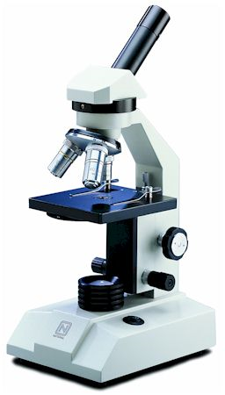

E Coarse adjustment

D Light

F Fine adjustment

B Objective Lens

C Stage

(3 marks)

1. What is the difference between the ocular and objective lenses of a microscope?

Ocular lens is the one you look directly into and the objective lens is the one near the object on the stage

(1 mark)

1. Without looking at the markings, how can you tell which objective lens has the greatest magnification?

Longest

(1 mark)

1. The monocular microscopes in this laboratory are equipped with an ocular of ×10 magnification. It also has objective lenses of ×4, ×10 and ×40.  
     
   Calculate the total magnification and fields of view and complete the table to show all the magnifications possible with this microscope and the field of view at each magnification, given the field of view at the lowest magnification.

|  |  |  |  |
| --- | --- | --- | --- |
| LENS COMBINATION | |  |  |
| OCULAR MAGNIFICATION | OBJECTIVE MAGNIFICATION | TOTAL MAGNIFICATION | FIELD OF VIEW DIAMETER (mm) |
| ×10 | ×4 | ×40 | 4.5 |
| ×10 | ×10 | ×100 | 1.8 |
| ×10 | ×40 | ×400 | 0.45 |

(3 marks)

1. Complete the following table for another monocular microscope.

|  |  |  |  |
| --- | --- | --- | --- |
| LENS COMBINATION | |  |  |
| OCULAR MAGNIFICATION | OBJECTIVE MAGNIFICATION | TOTAL MAGNIFICATION | FIELD OF VIEW DIAMETER (mm) |
| ×15 | ×4 | ×60 | 3.0 |
| ×15 | ×10 | ×150 | 1.2 |
| ×15 | ×40 | ×600 | 0.3 |

(3 marks)

1. This is a view of filamentous algae at ×100 magnification of another microscope.

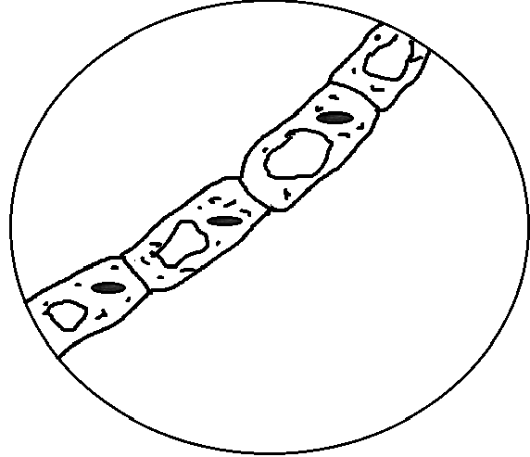

1. The average length of the alga cells is known to be 0.4 mm(400μm). What is the field of view of this microscope at this magnification?

1.2mm

1. Give the size of the alga cells when viewed at ×200 magnification.

0.4 mm

1. Approximately how many cells will fit across (lengthwise) at ×200 magnification?

1 1/2

(3 marks)

1. In the circle below, draw how you would expect to see the letter **d** if viewedunder the microscope.

**P**

(1 mark)

***END OF SECTION A***

**HUMAN BIOLOGY ATAR YEAR 11**

**TASK 1: MICROSCOPE TEST**

**SECTION B: (15 MARKS)**

*In this section of the test you will have to use the microscope to examine a prepared slide.*

***Please note: 1mm = 1000*μm**

1. Examine your slide under the **lowest** magnification possible. What is this **total magnification**?

×40

(1 mark)

1. Switch to the next highest magnification.

a What is this **total magnification**? ×100 (1 mark)

b Draw what you see in the circle below. Label a cell and include name of organism.

2 marks - diagram (-1 if not pencil)

1 mark - Multiple cells

1 mark – labels

1 mark – name of organism

(8 marks)

***PUT UP YOUR HAND TO ALLOW YOUR TEACHER TO COME AND CHECK YOUR MICROSCOPE***

1 mark - Focus correct

1 mark - Correct magnification

1. Switch to the **highest** magnification.

a What is this **total magnification**? ×400 (1 mark)

b Draw **one cell** in the circle below. Label the cell.

2 marks - diagram (-1 if not pencil)

1 mark – one cell

1 mark – labels

c If the field of view is 450μm (0.45mm), what is the approximate length of the cell?

1 mark - Determine size from their diagram

(6 marks)

***END OF SECTION B***

***(TOTALTEST: 30 MARKS)***